Abuse Awareness Steps
- Navigate to Abuse Awareness Little League Page
  - https://www.littleleague.org/university/articles/abuse-awareness-training-course/
- If you have an account click on “LOGIN TO TRAINING PORTAL”

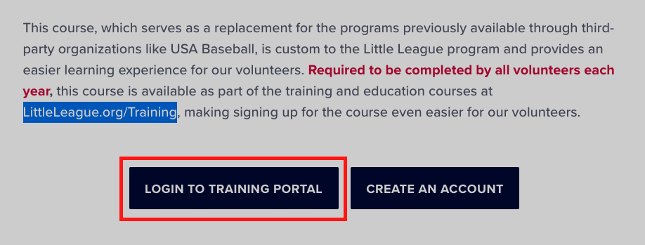
- Log in with your email and password
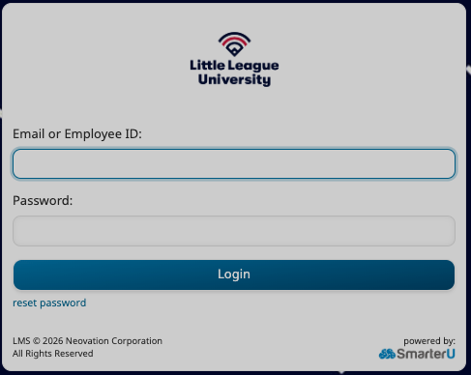

- If not click “CREATE AN ACCOUNT”

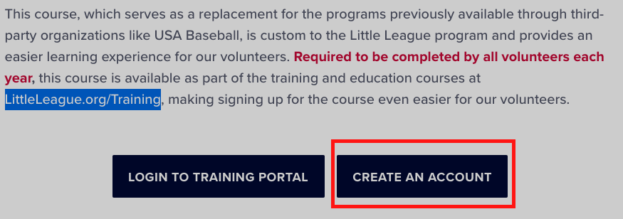

  - Fill out all the fields
    - I am a:
      - Select “Coach”
    - Fill out all the fields with your information
    - Under “Your Associated League”
      - Search for “Elkton” and you will select the “ELKTON LL (Elkton, MD) option
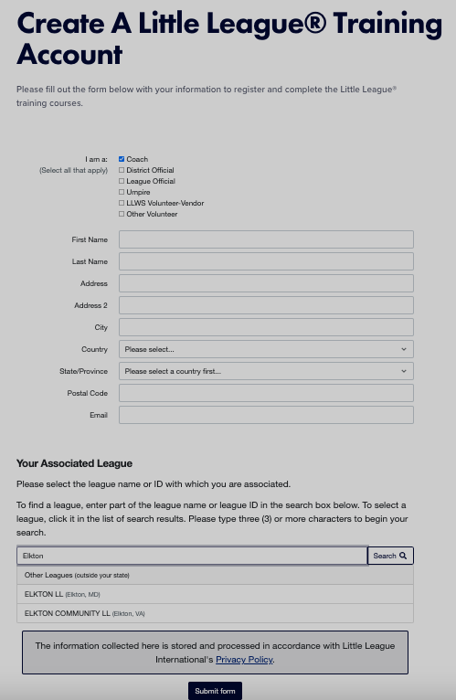

- Once you get logged in, select “Abuse Awareness 2026” on the left hand side

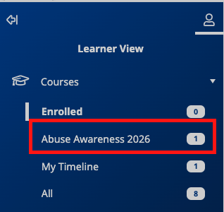

- Click on the Abuse Awareness 2026 on the right hand side (HINT: you can click anywhere in the line or click the down arrow on the right”
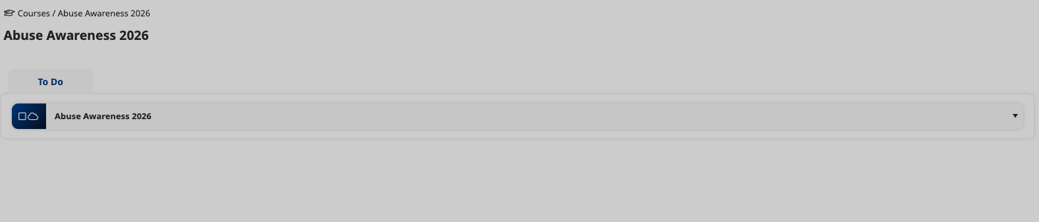

- Click “+ Enroll” Button

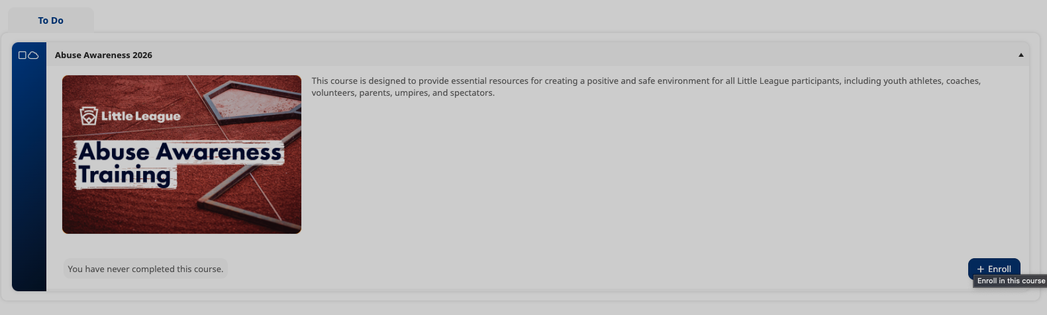

- Enroll button changes to “Start”, click “Start”

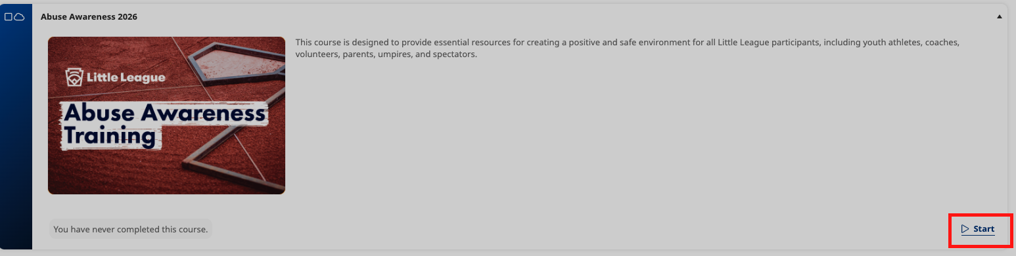

- Navigate through course and save certificate at the end
  - You must watch all the videos in order on the left hand side
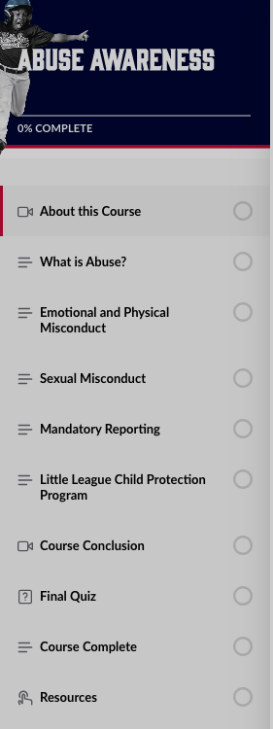

- Once you are complete with all the videos, you MUST save your cert for verification of completion
  - It will email you the certificate
  - OR
  - You can get it from your account
  - Back on the main page Follow steps above to click Abuse awareness on left hand side and expand the training in te right window (Steps 6/7)
  - Click on the “Date” link next to the enroll button
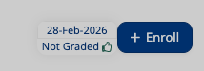

  - Click Certificate Button
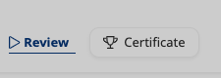

  - Print or save cert to get us a copy

